Supplemental Material, Design S2 (ABE-Stat 1_0_01 Wireless Potentiostat Prototype)

Schematic

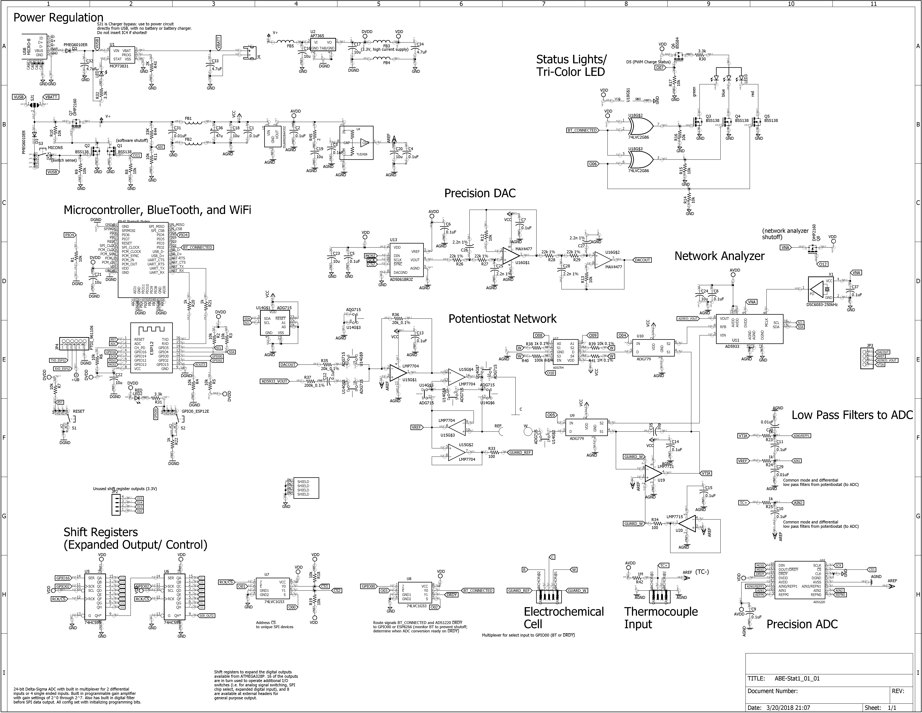

Layout

